Layout based on http://r1.template.expertagent.co.uk
This document outlines the standard set of content and imagery required from you to populate the standard 9 website navigation pages. Please work through each section below, where instructed, to gather the necessary content.
Responsive Theme 1
*While preparing written content please pay attention to key words and phrases in relation to search engine optimisation. More information on this can be found in our guide here http://showcase.client.expertagent.co.uk/additional-info/seo/
Home page
- Logo
Please provide a high-resolution copy of your logo in either of these formats:
Formats: .jpeg, .png, .eps.
- Facebook and Twitter urls
Please provide the direct web links to your Facebook and Twitter pages. Please provide the url’s to your pages.
- Email address and Telephone number
Please provide the email address and telephone number you would like to appear in the top section of the website.

Banner Image
A large photo is required for the banner section of the home page. The banner section can either be a static single photo, or an animated slideshow. If a slideshow is the preferred choice, please provide approx. 5x photos instead.
Format: .jpeg
Dimensions: A large high resolution photo which suits a landscape/panoramic proportion. We find something around a 1900px (w) by 500px (h) works quite well.

*Please note: The banner photo needs to compliment a landscape or ‘letterbox’ orientation, to match the available space, and how the images are cropped. For example a portrait photo of a skyscraper or church will not fit well, whereas a landscape rooftop scene will.
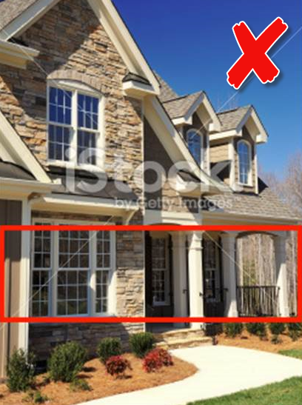
The below example demonstrates a good choice of banner photo, versus a bad choice. It also shows how the image will be cropped to fit into R1:

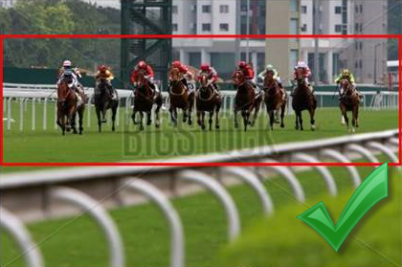
Overlaying text
We advise against adding text to your banner images, because when they resize for smaller screens it is highly likely it will either disappear off screen, or fall under the search.

We can instead add static text to the banner such as on this website: http://www.breakeyandco.com

- Welcome Text – approx. 100 Words
e.g.
“Welcome to Baxter’s Estate Agents, Bath, Somerset
Baxter’s Estate Agents specialise in residential sales and lettings, and also commercial and auction properties. Our experienced team can advise you on just about everything from decor to financial advice, we have it covered!
With over 150 years combined experience, and local knowledge covering Bath, Frome, Warminster and surrounding areas in South West England, you can be comfortable leaving the task of buying or selling your property in our hands. Please browse through our website to see exactly what we can offer.”

- Welcome Bullet Points
Please provide bullet points alongside the Welcome text if you would like to include them on your page.

- Call to Action #1 – approx. 20 Words
e.g.
“FREE VALUATION
Take advantage of a free no obligation valuation and our competitive selling fee of 1.5% + VAT and experience the difference for yourself!”

- Call to Action #2 – approx. 20 Words
e.g.
“REGISTER WITH US
Want to keep up to date with properties you might be interested in? Register with us to receive regular property updates”

- Call to Action #3 – approx. 20 Words
e.g.
“MORTGAGES
We have a dedicated financial team in to assist with any mortgage advice you may need! Click here for more details.”

- Latest Properties
This is an automated Expert Agent feature, selecting the latest properties from the system using the ‘instructed on’ date.

- Testimonials
Please provide up to 10 testimonials for placement in the animated slider, and an image to sit behind this section.

- Word count: Approx. 70 words each.
Format: .jpeg
Dimensions: A large high resolution photo which suits a landscape/panoramic proportion. We find something around a 1900px (w) by 300px (h) dimension works quite well.

- Get Social
Please provide your social media urls you would like to be displayed in this section and accompanying text.

- Contact Us
Please provide a short paragraph of text to be displayed alongside the enquiry form.

Latest Properties Page
Powered by Expert Agent, no text content required. Displays the latest properties from the last 14 days, using the ‘Instructed On’ date in Expert Agent (under the Dates tab of a property record).
For Sale Page
Powered by Expert Agent, no text content required.
To Let
Powered by Expert Agent, no text content required.
About Us Page
We have two possible layouts available for this page; with or without staff images.
*Please Note: The default layout will be set up without staff images, unless instructed otherwise.
Option 1 - Without Staff images
Company text will span the full width of the page.
Company Profile Word Count: Unlimited.

Option 2 - With up to 6x staff profiles (additional staff profiles will incur a charge to apply):
The company text will be positioned to the left of the page, with staff images and profiles to the right.
Company Profile Word Count: Approx. 250 Words
Staff Profile Word Count: No more than 50 Words each
Image Format: .jpeg
Our Services Page
The services text will occupy the full page.
Services Text Word Count: Unlimited.
Valuation Page
The valuation form contains a standard set of fields. We can hide any fields which are not relevant to your business.
Register Page
The register form integrates with Expert Agent. Any information submitted by a user will be automatically entered in to Expert Agent as a new applicant. You will receive email notification to confirm when a new applicant has registered via this method, and they will appear in your Applicant grid in Expert Agent. The applicant will receive a ‘Welcome’ email.
Contact Us Page
The contact us page displays a map feature plotting your branch, contact information relating to each of your branches and an enquiry form. Please provide the below information for each branch that you have:
- Branch Contact Information
e.g.
Expert Agent Head Office
57 Vallis Rd
Frome
Somerset
BA11 3EG

Telephone: 01225 303500
Email: sales@expertagent.co.uk
Opening Hours: Mon – Fri: 9am – 5.30pm

- Statutory Company Information
You are required by law to provide certain statutory information relating to your business such as the registered company number, address and VAT number, if applicable.

Other Required Information
- Please provide a Privacy Policy and any other required documentation for inclusion in your website in a .pdf format, which will be linked to from the website footer and adjacent to any forms.
- Should you choose to implement any 3rd party features into the website that are not supplied by us, please ensure that an updated cookie policy is provided to accommodate any additional cookies they may drop into the site.
- Please provide a negotiator name to be defined on the ‘Welcome’ communication sent out from the website. If you do not want to specify a certain negotiator, we suggest instead creating a fake negotiator in Expert Agent with a generic name and email address i.e. ‘Baxters Unreal Agents - sales@baxtersunrealagents.co.uk’
- Within our SEO Guide we suggest adding Google Analytics code to the website which will allow you to track the website stats and visitors’ information after it has gone live. If you would like to implement this, please provide us with the required code to apply to the website.
http://www.google.co.uk/analytics

How to find the Google Analytics code?
https://support.google.com/analytics/answer/1032385?hl=en

Extra Optional Features
The following extra features are available for integration in your website:
Instant Valuation Tool
Add our online automated valuation tool to your Expert Agent website to generate more leads and increase revenue.
Driving traffic to your website is great but getting visitors to leave their details is hard. Typical conversion rates are below 1%.
Increase your chance of converting them by offering an instant valuation when they arrive. Offer vendors and landlords something they want you’ll get richer data in return.
Leads will appear instantly in your Expert Agent, ready for you to process. Save time keying in data and start booking market appraisals straight away.
Contact our Account Managers on account.managers@webskyltd.com for more information.
Blog Feature
Keep your customers up to date and help improve seo and exposure to your website at the same time.
We have an integrated blog feature which can be included for a one-off setup fee of £80+vat. The feature will allow you to add/edit/delete blog posts, and upload images via a front-end editor access. It will also will allow you to apply a meta description and keywords to each post, to benefit search engine optimisation. Login details for accessing the page are provided after website sign off.
An example of the blog page on your chosen theme can be viewed here - http://r1.template.expertagent.co.uk/blog
If you are interested in having a blog page on the website please let us know.
Area Pages
Extra ‘area’ landing pages can prove helpful for search engine optimisation, based on the areas your business covers. They can provide useful information for your customers, such as general information about the town, property prices, facilities etc, and could also show a selection of properties. They provide useful for SEO because they will contain important keywords relevant to your business and a particular area, and help direct traffic back to your website.
If you are interested in displaying area pages on your website please let us know and we can provide a quotation and confirmation of what the page will contain.
Have Other Questions?
Please visit out useful FAQs guide online here - http://showcase.client.expertagent.co.uk/additional-info/website-faqs/

